**LAB ASSIGNMENTS**

Akshit Puri

Cyber Security, Loyalist College of Applied Arts and Technology

CYSE2001: Secure Network Infrastructure

Instructor: Peter Wheeler

23rd September 2022

**LAB – 3 (OSI Model)**

Network Set-up:

Analyzing Traffic through simulation mode:

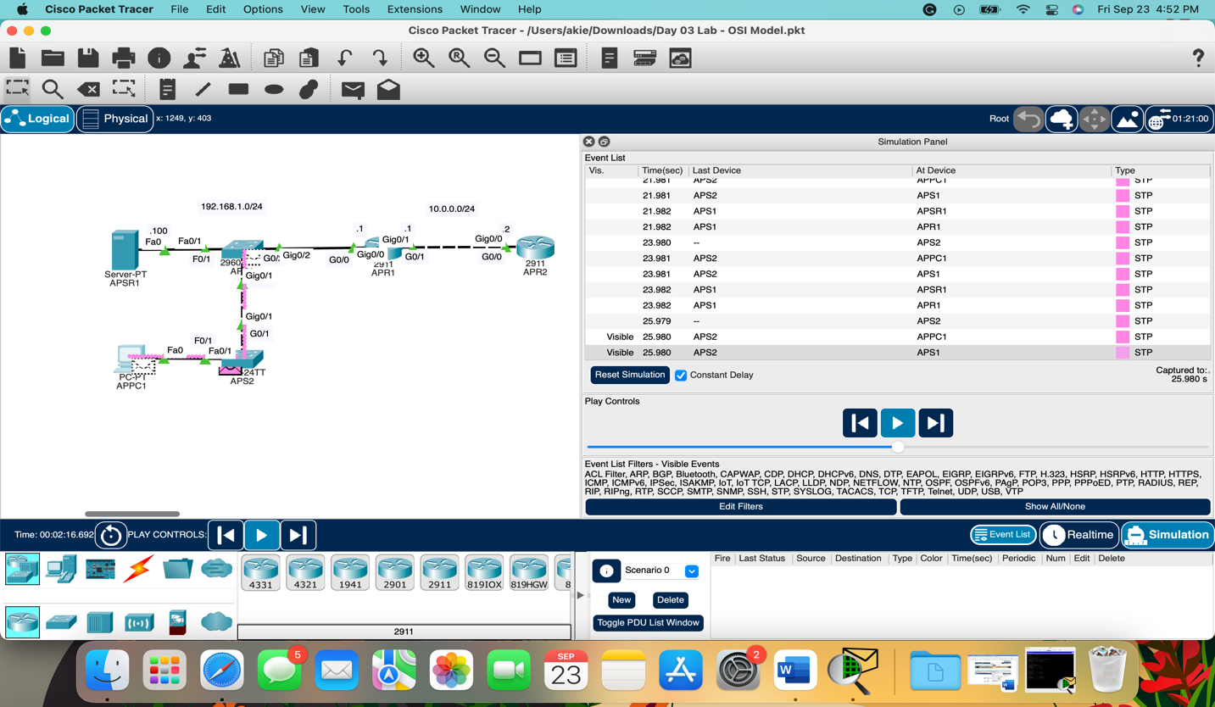

Releasing and renewing PC1’s IP address:

It took 1 hour to make and analyze the network.

I didn’t face any issues, but I am trying the simulation mode for the first time, so it takes time to analyze each packet and check the OSI Model to get detailed information.

**LAB – 4 (Basic Device Security)**

Network Set-up:

To get in global configuration mode:

Setting Hostname for Router:

Setting Hostname for Switch:

Configuring Unencrypted Enable Password:

Viewing Password in Running Configuration Mode:

Enabling Password Encryption:

Enabling More Secure Encrypted Password:

Setting up the network and configuring the router took around 45 minutes.

I didn’t face any issues. I love using this command line interface.